File Creation Task

Step1:

Created an directory using mkdir myfolder and navigate into that directory using ls

Both screenshot attached below

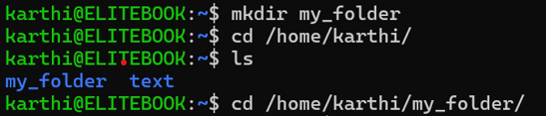

Step2 :

Created 2 txt file with some content the file name is my_file.txt and another_file.txt

Screenshot attached below

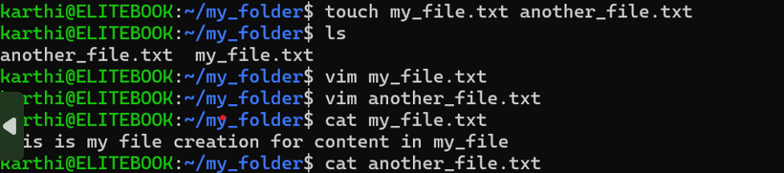

Step 3:

Then concatenated the another_file into my_file by using cat >> command

Screenshot attached below



Step 4:

Then I created One more directory for storing that 20 test using touch command

Screenshot attached below



Step 5:

Then for rename the first 5 into yml using this command ls *.txt | head -n 5 | while read file; do mv "$file" "${file%.txt}.yml"; done and latest created show in first top 5 using ls –lt command

Screenshot attached in below

